6. Project Testing Phase
Project: Implement Client Script & UI Policy (ServiceNow)

Phase Objective
The implemented configuration is checked through the form. Values are entered, conditions are triggered, and the visible behavior of the form is observed to identify whether the configured rules work as expected.

Activities Covered
- Enter test values in the form.
- Trigger the configured conditions.
- Check visible changes and correct any unexpected behavior.

Screenshots from the Project Video
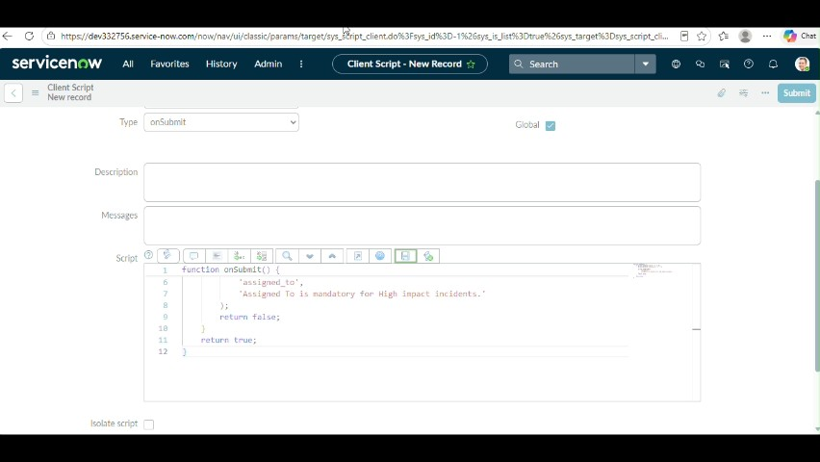
Figure 1: Project video screen at approximately 300 seconds.
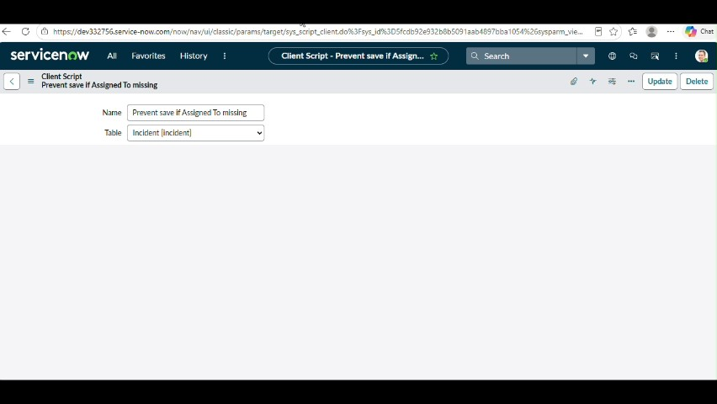
Figure 2: Project video screen at approximately 308 seconds.
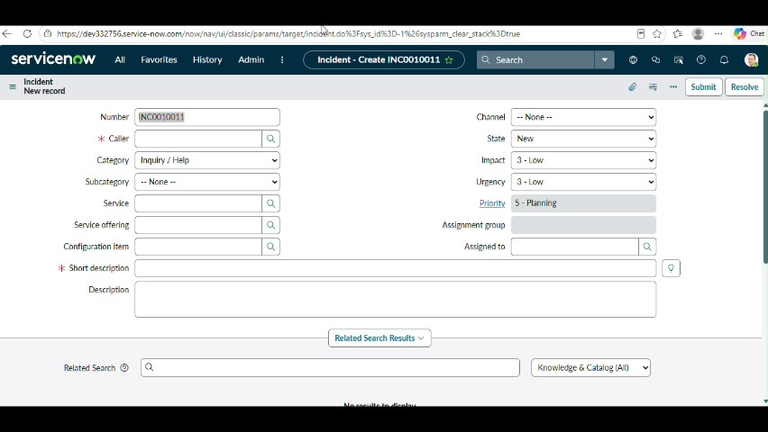
Figure 3: Project video screen at approximately 324 seconds.
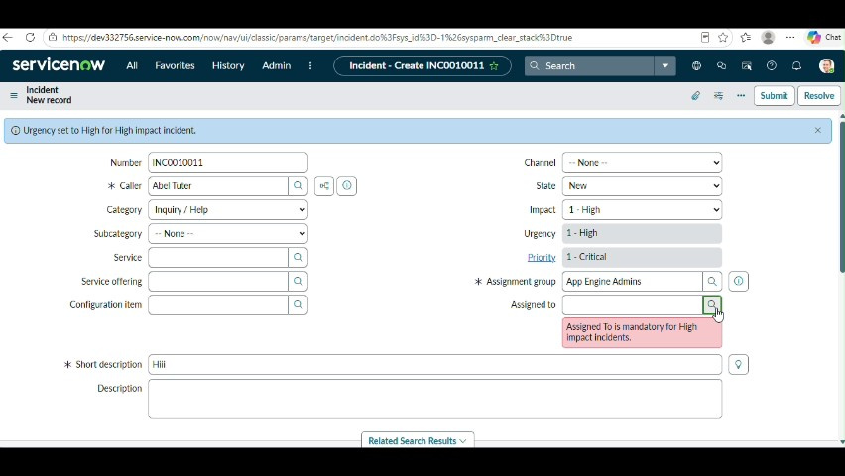
Figure 4: Project video screen at approximately 342 seconds.
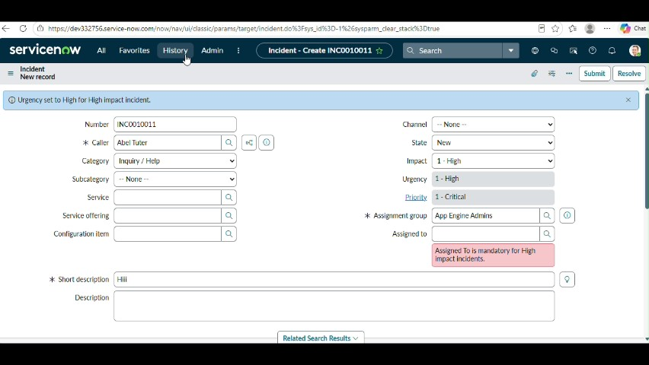
Figure 5: Project video screen at approximately 355 seconds.

Phase Outcome
The implemented behavior is checked through practical form-level testing.
Prepared from the supplied project demonstration video

